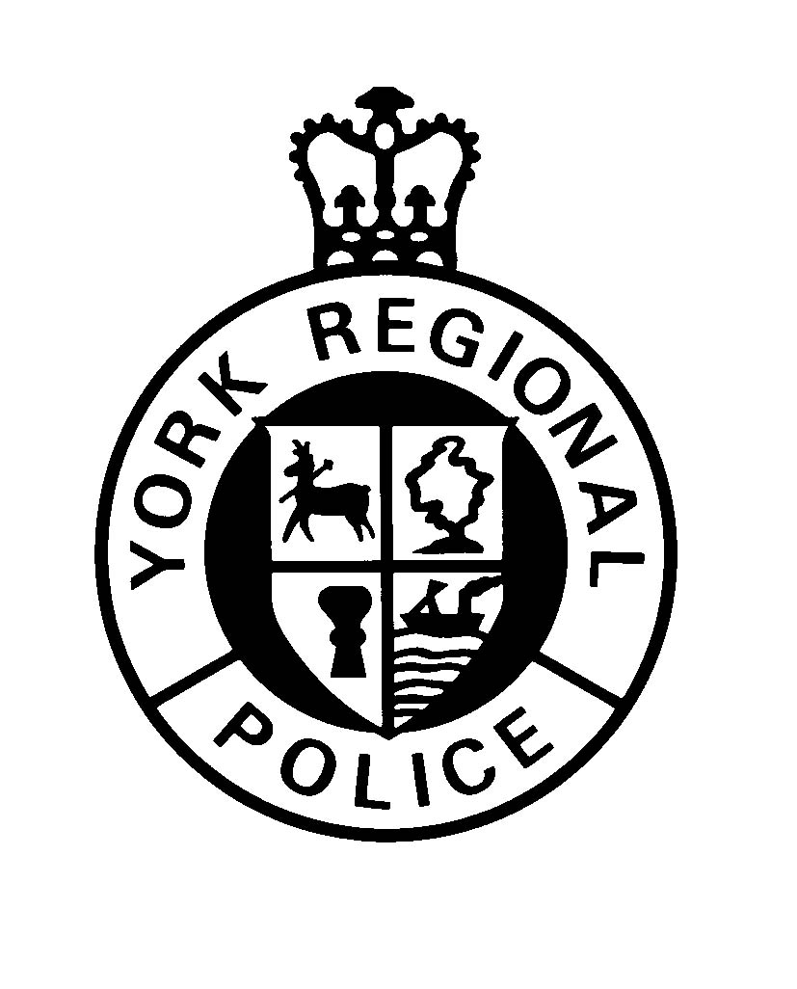

BUSINESS EMERGENCY DIRECTORY FORM

The information requested on the reverse side of this form is required by York Regional Police to enable
us to respond to your needs more effectively. It is essential that an up to date list of Company Officials be
maintained.
Please complete (CLEARLY PRINT ALL INFORMATION) and return to:
York Regional Police
Alarm Office: Attention Alarm Co-ordinator
47 Don Hillock Drive
Aurora, Ontario
L4G 0S7
Or Fax To: (905) 895-7264
Email: alarmprogram@yrp.ca
If any of the information supplied changes, please forward a revised form to the above address immediately.
THANK YOU FOR HELPING US TO SERVE YOU BETTER
Personal information on this form is collected under the authority of the Ontario Police Services Act,
S.41 and will be used to contact persons in cases of emergency or if a premise is found to be insecure.
Questions about this collection should be directed to York Regional Police, Officer in Charge,
Information Services.

Business Name:
Address: |  |  |  |  |  |  |  |  |  |  |  |  |  |  |  |  |  |  |  |  |  |  | Postal Code:
Municipality: |  |  |  |  |  |  |  |  |  |  |  |  |  |  |  |  |  |  |  |  | Unit:
Type of Business: |  |  |  |  |  |  |  |  |  |  |  |  |  |  |  |  | Telephone Number:
Access: |  |  |  |  |  |  |  |  |  |  |  |  |  |  |  |  |  |  |  |  |  | Watchman: |  |  |  |  |  |  |  |  |  | Dog:
Safe: |  |  |  |  |  |  |  |  |  | Location: |  |  |  |  |  |  |  |  |  |  |  | Visible: |  |  |  |  |  |  |  |  | Alarmed:
Hazardous Materials and/or firearms on site:
In Case of Emergency Notify:
Owner/President:
Address: |  |  |  |  |  |  |  |  |  |  |  |  |  |  |  |  |  | Telephone No. 1:
 |  |  |  |  |  |  |  |  |  |  |  |  |  |  |  |  |  | Telephone No. 2:
Name: |  |  |  |  |  |  |  |  |  |  |  |  |  |  |  |  |  | Position:
Address: |  |  |  |  |  |  |  |  |  |  |  |  |  |  |  |  |  | Telephone No. 1:
 |  |  |  |  |  |  |  |  |  |  |  |  |  |  |  |  |  | Telephone No. 2:
Name: |  |  |  |  |  |  |  |  |  |  |  |  |  |  |  |  |  | Position:
Address: |  |  |  |  |  |  |  |  |  |  |  |  |  |  |  |  |  | Telephone No. 1:
 |  |  |  |  |  |  |  |  |  |  |  |  |  |  |  |  |  | Telephone No. 2:
Note: |  | The Chief of Police or designate, or any other member of York Regional Police or the Regional
 |  | Municipality of York, shall not be held liable for any loss or damage which results from or can be
 |  | reasonable attributed to the failure of a company official to respond when requested to do so by any
 |  | member of York Regional Police or where York Regional Police is unable to contact such official(s)
 |  | or the information supplied is not accurate.
Completed by: |  |  |  |  |  |  |  |  |  |  |  |  |  |  |  | Position:
Signature: |  |  |  |  |  |  |  |  |  |  |  |  |  |  |  | Date:

