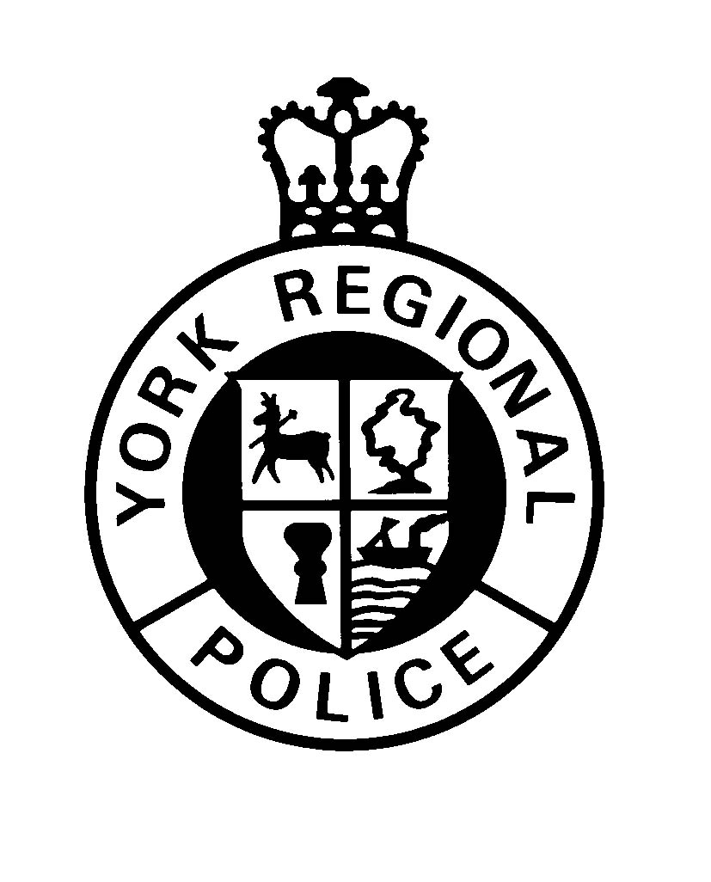

Motor Vehicle and

General Occurrence Report Request

Request

 |  | Mandatory Fee must accompany all requests.
Request for:

Motor Vehicle Collision Report
Non-Reportable Motor Vehicle Collision Report
 | General Occurrence Report for Proof of Loss
Information of Requestor:
Last Name:
First Name: |  |  |  |  |  | Middle name:
Address (Street / Apt. No. / P.O.Box No. / R.R No.) |  |  |  |  |  |  | City/Town |  |  |  |  |  |  | Province
Postal Code |  |  | Date of Birth | Telephone No: |  |  |  |  |  |  | Email Address
Occurrence Details:

Occurrence Number:

Date of Occurrence:

Please indicate below your preferred method to receive the above requested report
Preferred method of access to records: |  |  |  | Email |  |  |  |  | Mail
Signature |  |  |  |  |  | Date
FOR POLICE USE ONLY
Date Received: (ddmmyy): |  |  |  |  | Request Number:
Comments:
Personal information contained on this form is collected pursuant to the Municipal Freedom of Information of Privacy Act, and will be used for the purpose of responding to your request. Questions about this collection should be directed to York Regional Police, 47 Don Hillock Drive, Aurora, Ontario L4G 0S7: Attention Information Management Bureau. Tel: (905) 830-0303, extension 7878.

