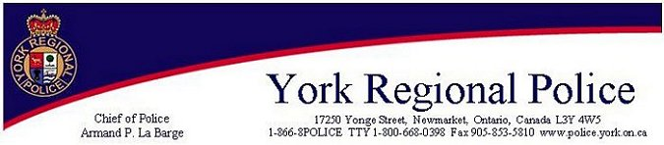

Cottage Watch is here!

The York Regional Police Marine Unit have initiated a Cottage Watch Program for all seasonal residents in the Lake Simcoe patrol area within York Region. In an attempt to reduce crimes against property, the York Regional Police will conduct periodic spot checks of properties in the area and notify you in case of an emergency.

Please complete the attached registration form and return it to:

York Regional Police
17250 Yonge Street
Newmarket, Ontario
L3Y 4W5

Or bring this form in person to:
3 District Headquarters
3527 Baseline Rd,
Sutton West, Ontario

Attention: Marine Unit

Seasonal Property Contact Person

 | Name:
Address: | Address:
 | City/Town:
City/Town: | Phone Numbers: Home:
 | Business: Cell:

