First Step – Create Your Careers Profile!
- Visit our website at https://jobs.yrp.ca/

- Click to accept cookies at the top of the screen

- Click on “View Careers Profile” top right corner of the screen

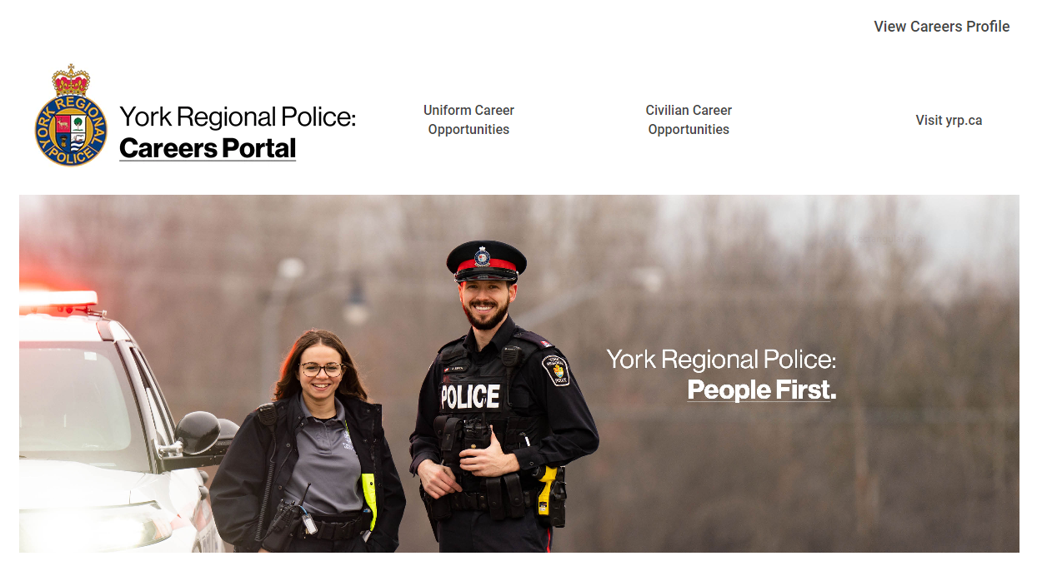

- Click on “Create an account”

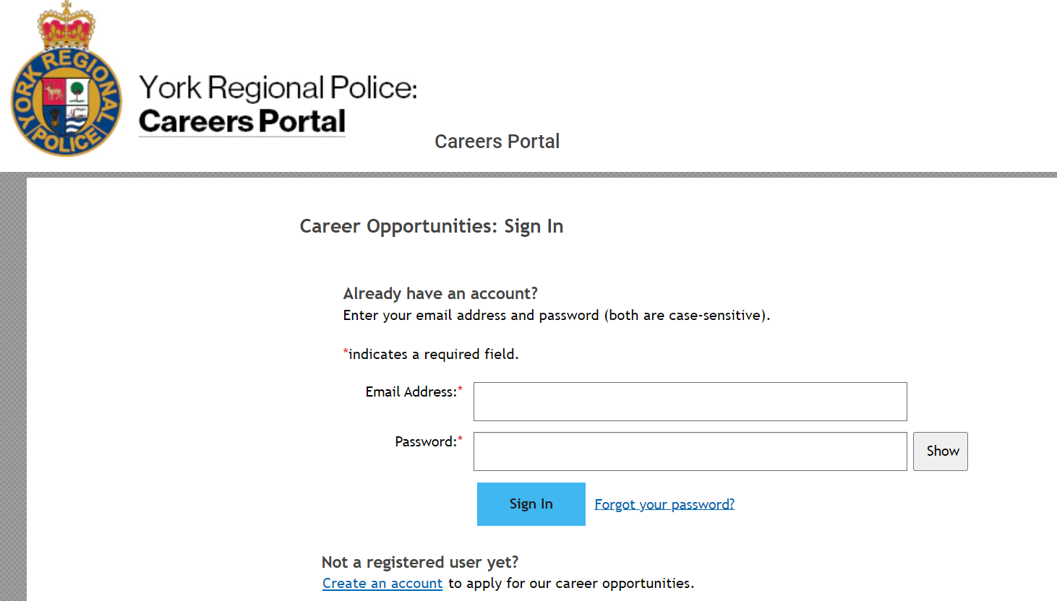

- Enter the information to create a new account – note that all fields marked with an asterisk are mandatory to complete (*):
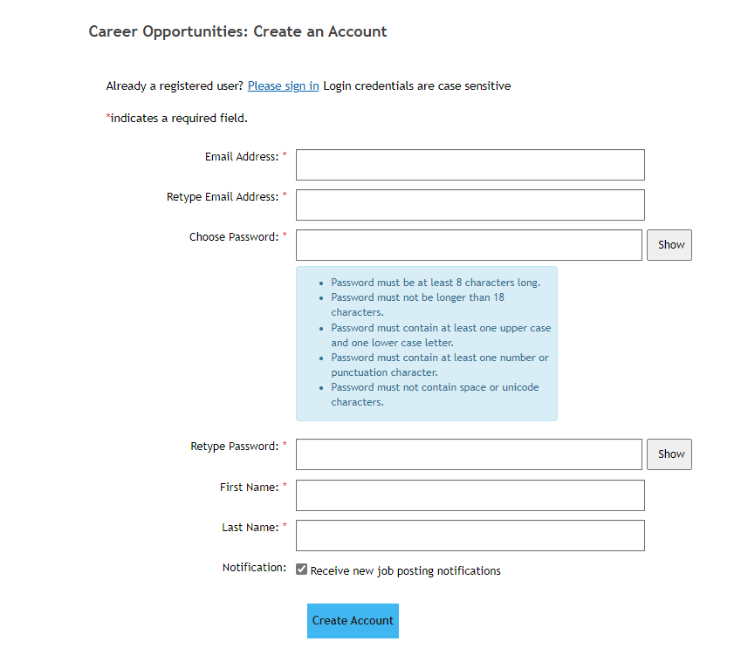

- Click “Create Account” to finish creating your profile

- Click on “My Documents” to begin uploading your application documents. You can also click through each section to complete your education information, employment information, volunteer information, previous agency applications, etc.

Note that when you apply for any of our job postings, your information from this section will be automatically uploaded into your application(s), and you will not be required to re-enter the information.

When you have completed each section, click “Save” at the bottom of the screen to save your information.

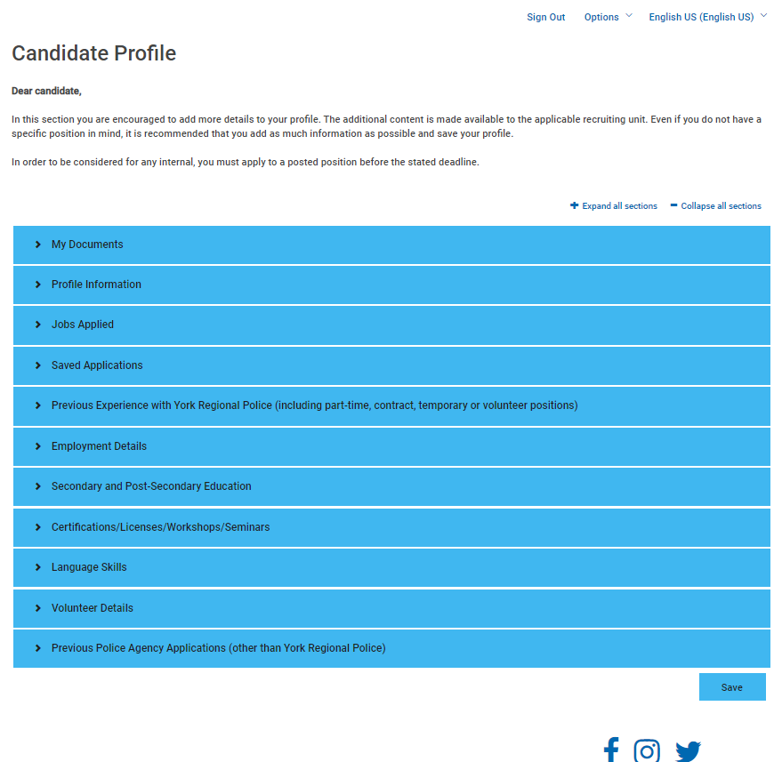

Second Step – Upload Your Mandatory Documents!
MANDATORY DOCUMENTS FOR POLICE CONSTABLE APPLICATIONS
The following documents are mandatory in order to submit a Police Constable application to us. Note that applications missing any of these documents cannot be processed until all documents have been uploaded. You will also be required to name each of your documents exactly as shown below – note that your Recruiter may ask you to rename/reupload any documents that are not labelled correctly.
DOCUMENT REQUIRED  FOR APPLICATION | WHAT TO NAME YOUR DOCUMENT
Valid OACP Certificate  (Please visit www.oacpcertificate.ca for more information) | OACP.pdf
Vision and Hearing Assessment Results  (We can only accept Canadian results on official OACP vision and hearing forms – please upload your assessment sheets only, not the entire OACP medical booklet) | Vision_Hearing.pdf  (if combining both assessments into one file) OR  Vision.pdf  Hearing.pdf  (if uploading your assessments separately)
OACP Fitness Logs  (Combine all logs/journals into one file) | Fitness Logs.pdf
Standard First Aid/CPR-C Certificate  (Canadian assessments only – certification must remain valid through the recruitment process) | First Aid_CPR.pdf
Secondary School Diploma(s) OR Letter from your High School on official letterhead confirming your attendance and graduation date, with a high school diploma having been obtained | HS Diploma.pdf  OR  HS Diploma-1.pdf, HS Diploma-2.pdf, etc.  (if uploading multiple diplomas)
Secondary School Transcripts | HS Transcript.pdf  OR  HS Transcript-1.pdf, HS Transcript-2.pdf, etc.  (if uploading multiple transcripts)
Post-Secondary School Diploma(s) | PS Diploma.pdf  OR  PS Diploma-1.pdf, PS Diploma-2.pdf, etc.  (if uploading multiple diplomas)
Post-Secondary School Transcripts | PS Transcripts.pdf  OR  PS Transcript-1.pdf, PS Transcript-2.pdf, etc.  (if uploading multiple transcripts)
Educational Equivalency Certificate  (To validate secondary school and/or post-secondary school obtained outside of Canada. For more information on obtaining an Equivalency certificate, visit our website at Resources - York Regional Police (yrp.ca) | Equivalency.pdf
Consent and Release of Liability Waiver Form | Waiver.pdf
Confidential Applicant Survey | Survey.pdf
MANDATORY DOCUMENTS FOR EXPERIENCED OFFICER APPLICATIONS
Applicants qualify to apply through this intake if they are currently employed as a Police Constable with a Canadian Police Service, and have completed their probationary period. Canadian Military Police Officers will be considered if they have obtained their QL5 qualification. The following documents are mandatory in order to submit an Experienced Police Constable application to us. Note that applications missing any of these documents cannot be processed until all documents have been uploaded. You will also be required to name each of your documents exactly as shown below – note that your Recruiter may ask you to rename/reupload any documents that are not labelled correctly.
DOCUMENT REQUIRED  FOR APPLICATION | WHAT TO NAME YOUR DOCUMENT
Standard First Aid/CPR-C Certificate  (Canadian assessments only – certification must remain valid through the recruitment process) | First Aid_CPR.pdf
Secondary School Diploma(s) OR Letter from your High School on official letterhead confirming your attendance and graduation date, with a high school diploma having been obtained | HS Diploma.pdf  OR  HS Diploma-1.pdf, HS Diploma-2.pdf, etc.  (if uploading multiple diplomas)
Secondary School Transcripts | HS Transcript.pdf  OR  HS Transcript-1.pdf, HS Transcript-2.pdf, etc.  (if uploading multiple transcripts)
Post-Secondary School Diploma(s) | PS Diploma.pdf  OR  PS Diploma-1.pdf, PS Diploma-2.pdf, etc.  (if uploading multiple diplomas)
Post-Secondary School Transcripts | PS Transcript.pdf  OR  PS Transcript-1.pdf, PS Transcript-2.pdf, etc.  (if uploading multiple transcripts)
Educational Equivalency Certificate  (To validate secondary school and/or post-secondary school obtained outside of Canada. For more information on obtaining an Equivalency certificate, visit our website at Resources - York Regional Police (yrp.ca) | Equivalency.pdf
Ontario Police College Diploma, OPC Transcript/student evaluation marks, or other approved Canadian training facility | OPC Docs.pdf  (can be scanned together as one file)
Proof of current Fitness Assessment result  (PIN, PARE, POPAT, PREP) | Fitness.pdf
Comprehensive list of all training/courses completed | Training.pdf
Consent and Release of Liability Waiver Form | Waiver.pdf
Confidential Applicant Survey | Survey.pdf

MANDATORY DOCUMENTS FOR SPECIAL CONSTABLE APPLICATIONS
The following documents are mandatory in order to submit a Special Constable application to us. Note that applications missing any of these documents cannot be processed until all documents have been uploaded. You will also be required to name each of your documents exactly as shown below – note that your Recruiter may ask you to rename/reupload any documents that are not labelled correctly.

DOCUMENT REQUIRED  FOR APPLICATION | WHAT TO NAME YOUR DOCUMENT
Valid OACP Certificate  (Please visit www.oacpcertificate.ca for more information) | OACP.pdf
Vision and Hearing Assessment Results  (We can only accept Canadian results on official OACP vision and hearing forms – please upload your assessment sheets only, not the entire OACP medical booklet) | Vision_Hearing.pdf  (if combining both assessments into one file) OR  Vision.pdf  Hearing.pdf  (if uploading your assessments separately)
OACP Fitness Logs  (Combine all logs/journals into one file) | Fitness Logs.pdf
Standard First Aid/CPR-C Certificate  (Canadian assessments only – certification must remain valid through the recruitment process) | First Aid_CPR.pdf
Secondary School Diploma(s) OR Letter from your High School on official letterhead confirming your attendance and graduation date, with a high school diploma having been obtained | HS Diploma.pdf  OR  HS Diploma-1.pdf, HS Diploma-2.pdf, etc.  (if uploading multiple diplomas)
Secondary School Transcripts | HS Transcript.pdf  OR  HS Transcript-1.pdf, HS Transcript-2.pdf, etc.  (if uploading multiple transcripts)
Post-Secondary School Diploma(s) | PS Diploma.pdf  OR  PS Diploma-1.pdf, PS Diploma-2.pdf, etc.  (if uploading multiple diplomas)
Post-Secondary School Transcripts | PS Transcript.pdf  OR  PS Transcript-1.pdf, PS Transcript-2.pdf, etc.  (if uploading multiple transcripts)
Educational Equivalency Certificate  (To validate secondary school and/or post-secondary school obtained outside of Canada. For more information on obtaining an Equivalency certificate, visit our website at Resources - York Regional Police (yrp.ca) | Equivalency.pdf
Consent and Release of Liability Waiver Form | Waiver.pdf
Confidential Applicant Survey | Survey.pdf

MANDATORY DOCUMENTS FOR AUXILIARY APPLICATIONS
The following documents are mandatory in order to submit an Auxiliary application to us. Note that applications missing any of these documents cannot be processed until all documents have been uploaded. You will also be required to name each of your documents exactly as shown below – note that your Recruiter may ask you to rename/reupload any documents that are not labelled correctly.
DOCUMENT REQUIRED  FOR APPLICATION | WHAT TO NAME YOUR DOCUMENT
Auxiliary “Rules of Participation” Form | ROP.pdf
Standard First Aid/CPR-C Certificate  (Canadian assessments only – certification must remain valid through the recruitment process) | First Aid_CPR.pdf
Secondary School Diploma(s) OR Letter from your High School on official letterhead confirming your attendance and graduation date, with a high school diploma having been obtained | HS Diploma.pdf  OR  HS Diploma-1.pdf, HS Diploma-2.pdf, etc.  (if uploading multiple diplomas)
Secondary School Transcripts | HS Transcript.pdf  OR  HS Transcript-1.pdf, HS Transcript-2.pdf, etc.  (if uploading multiple transcripts)
Post-Secondary School Diploma(s) | PS Diploma.pdf  OR  PS Diploma-1.pdf, PS Diploma-2.pdf, etc.  (if uploading multiple diplomas)
Post-Secondary School Transcripts | PS Transcript.pdf  OR  PS Transcript-1.pdf, PS Transcript-2.pdf, etc.  (if uploading multiple transcripts)
Educational Equivalency Certificate  (To validate secondary school and/or post-secondary school obtained outside of Canada. For more information on obtaining an Equivalency certificate, visit our website at Resources - York Regional Police (yrp.ca) | Equivalency.pdf
Consent and Release of Liability Waiver Form | Waiver.pdf
Confidential Applicant Survey | Survey.pdf

Third Step – Apply for a Position!
Now that you have created your candidate profile and uploaded all your mandatory application documents, you are ready to apply for a position! Just make sure to click “Submit” on the job posting, to ensure that we receive your documents. Your application will be processed within two business days, and you will be sent a confirmation email to let you know we have received your information.

If you submit your application missing any of your mandatory application documents, you will be sent an email detailing what documents we require in order to continue processing your application. Note that you will have 30 days to upload your missing documents, otherwise your application will be closed.

Once your application file is complete, it will then be assigned to a Uniform Recruiter who will contact you to introduce themselves and provide you with information on next steps in the recruitment and selection process.

We sincerely appreciate your interest in a career with York Regional Police, and wish you the very best of luck through the process! If you need any assistance or information, please reach out to your Recruiter at any time, or email the Uniform Recruiting Unit general email at recruiting@yrp.ca, and any of our members would be very happy to assist you.

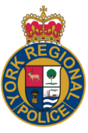 | York Regional Police  47 Don Hillock Dr, Aurora ON  1-866-876-5423 ext. 6720  recruiting@yrp.ca





YRP is hiring! Visit York Regional Police Careers for more info!

NEED TO UPDATE YOUR APPLICATION INFORMATION?
It’s easy and fast to update your candidate profile information or add new documents! Just login to your candidate profile and add the applicable information in the “Supporting Documents” section. This may include changes to your personal information such as address or phone number, adding courses completed, updating employment or volunteer work details, adding certifications/licences etc. Make sure to email your Recruiter to let them know you have updated your profile!
Note that you are unable to attach documents to the application itself once you have submitted it to us.

